CCNP ROUTING AND SWITCHING

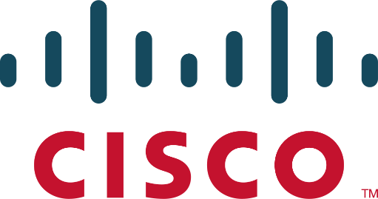

AWS RDS

B Brennen Tse . 5/27/2022

Task 1: Create a Security Group for the RDS DB Instance

Choose **VPC** in the **AWS Management Console**

Choose **Security Groups** in the left navigation pane

Choose Create security group and then configure:

* **Security group name:** DB Security Group
* **Description:** Permit access from Web Security Group
* **VPC:** *Lab VPC*

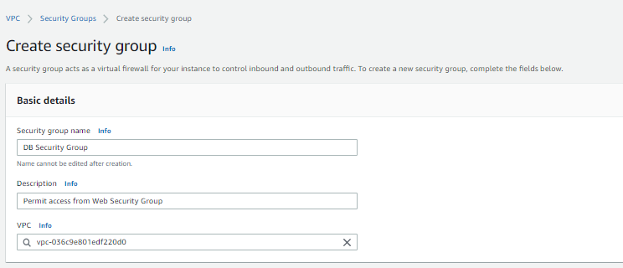

Choose **Add rule** in the **Inbound rules** pane

-Add a rule to permit access from the **Web Security Group**

Configure the following settings:

* **Type:** *MySQL/Aurora (3306)*
* **CIDR, IP, Security Group or Prefix List:** Type sg and then select *Web Security Group*.

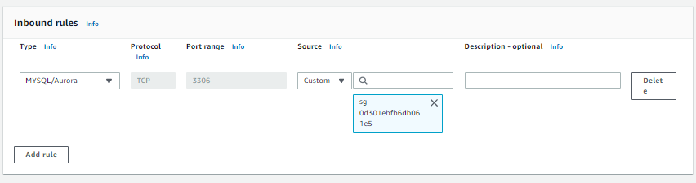

Choose **Create security group**

**Task 2: Create a DB Subnet Group**

Choose **RDS** from the **Services** menu

Choose **Subnet groups** from the left navigation pane

Choose Create DB **Subnet** **Group** then configure:

1. Choose Create DB Subnet Group then configure:
   * **Name:** DB-Subnet-Group
   * **Description:** DB Subnet Group
   * **VPC:** *Lab VPC*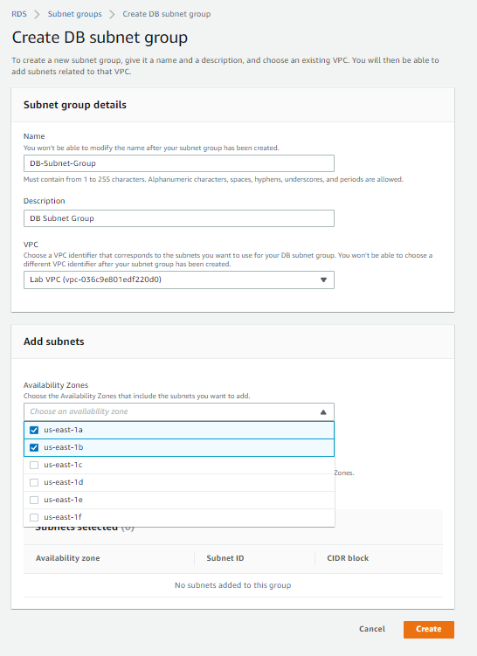

Scroll down to the **Add Subnets** section

Select the first two zones; us-east-1a and us-east-1b from the values under Availability Zones

Select the subnets of 10.0.1.0/24 and 10.0.3.0/24 under subnets then create the group

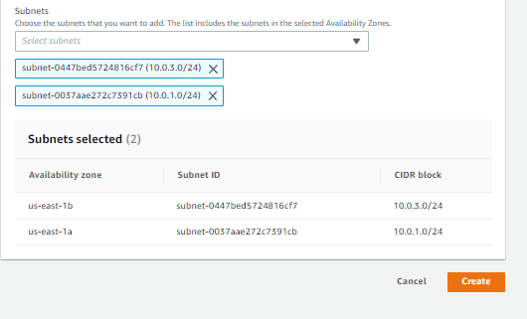

Task 3: Create an Amazon RDS DB Instance

Select **Databases** in the left navigation pane

Create **database** or **switch to the new database creation flow**

Select **MySQL**

Under Settings, configure:

* + **DB instance identifier:** lab-db
  + **Master username:** main
  + **Master password:** lab-password
  + **Confirm password:** lab-password
  + 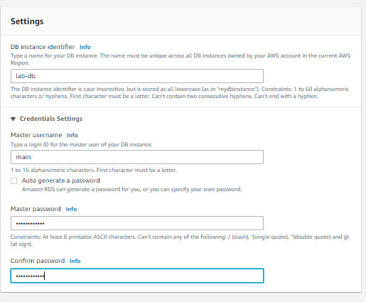

1. Under **DB instance class**, configure:
   * Select **Burstable classes (includes t classes)**.
   * Select *db.t3.micro*
2. 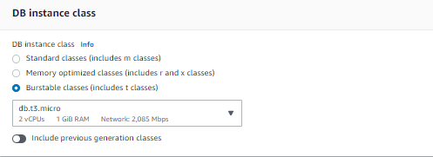
3. Under **Storage**, configure:
   * **Storage type:** *General Purpose (SSD)*
   * **Allocated storage:** *20*
   * 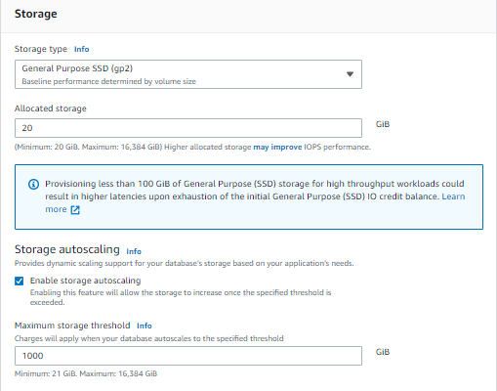
4. Under **Connectivity**, configure:
   * **Virtual Private Cloud (VPC):** *Lab VPC*
5. Under **Existing VPC security groups**, from the dropdown list:
   * Choose *DB Security Group*.
   * Deselect *default*.
   * 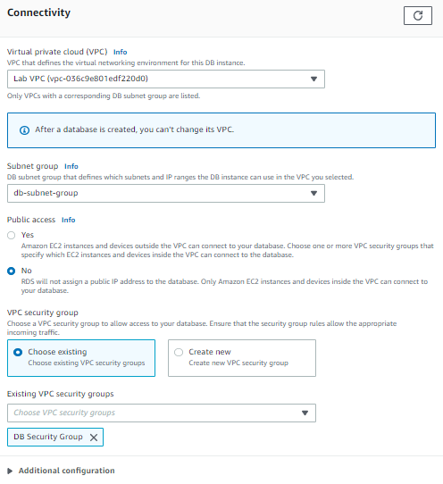
6. Expand **Additional configuration**, then configure:
   * **Initial database name:** lab
   * Uncheck **Enable automatic backups**.
   * Uncheck **Enable encryption**
   * Uncheck **Enable Enhanced monitoring**.

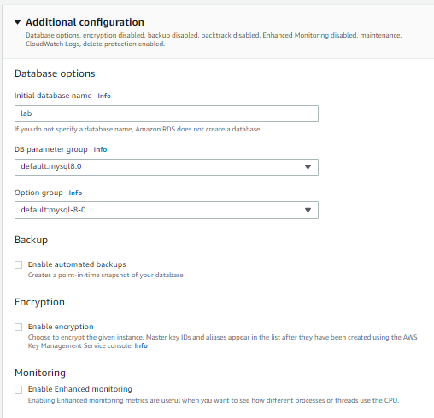

Choose **Create database**

Choose **lab-db**

Wait until Info changes to **Modifying** or **Available**

**Scroll down to the Connectivity and Security section and copy the Endpoint field**

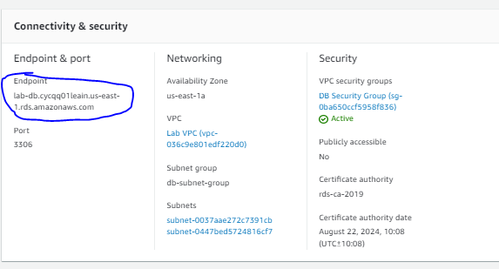

**Paste the Endpoint value into a text editor**

lab-db.cycqq01leain.us-east-1.rds.amazonaws.com

1. To copy the **WebServer** IP address, choose on the Details drop down menu above these instructions, and then choose Show.
2. Open a new web browser tab, paste the *WebServer* IP address and press Enter.

The web application will be displayed, showing information about the EC2 instance.

1. Choose the **RDS** link at the top of the page.

You will now configure the application to connect to your database.

1. Configure the following settings:
   * **Endpoint:** Paste the Endpoint you copied to a text editor earlier
   * **Database:** lab
   * **Username:** main
   * **Password:** lab-password
   * Choose **Submit**

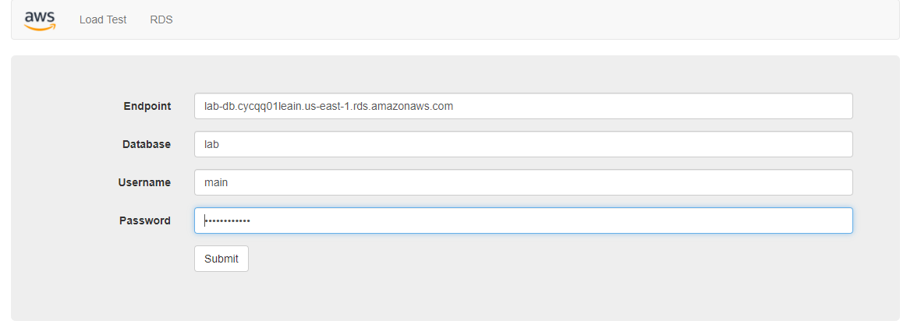

A message will appear explaining that the application is running a command to copy information to the database. After a few seconds the application will display an **Address Book**.

The Address Book application is using the RDS database to store information.

1. Test the web application by adding, editing and removing contacts.

The data is being persisted to the database and is automatically replicating to the second Availability Zone.

